30/12/2023

Chakradhar Bhogapurapu. BIBA

Azure Databricks

Visualization in Databricks notebooks.

🡪We need to create a cluster 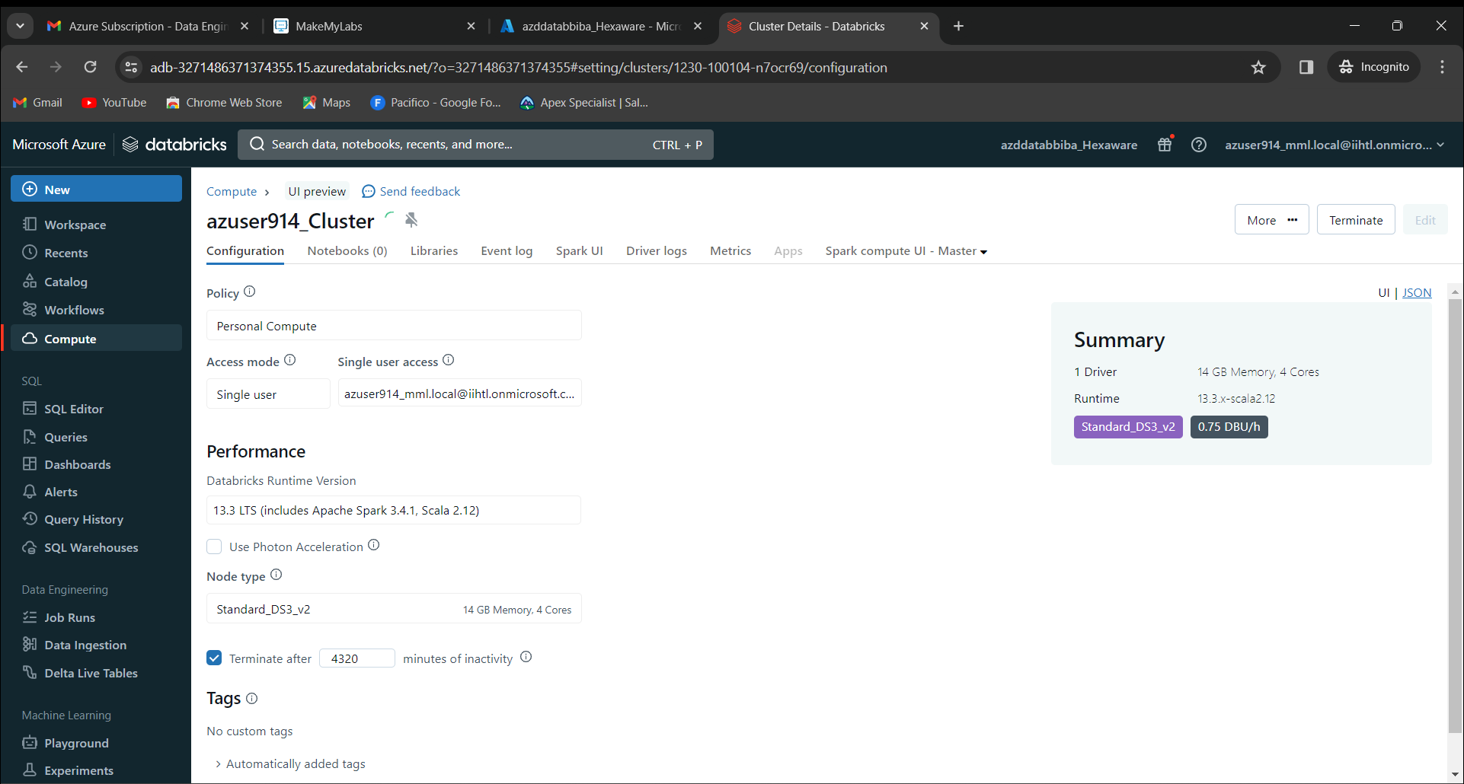

After creating a cluster, we need to click the option as “new”. In new, click “notebook”

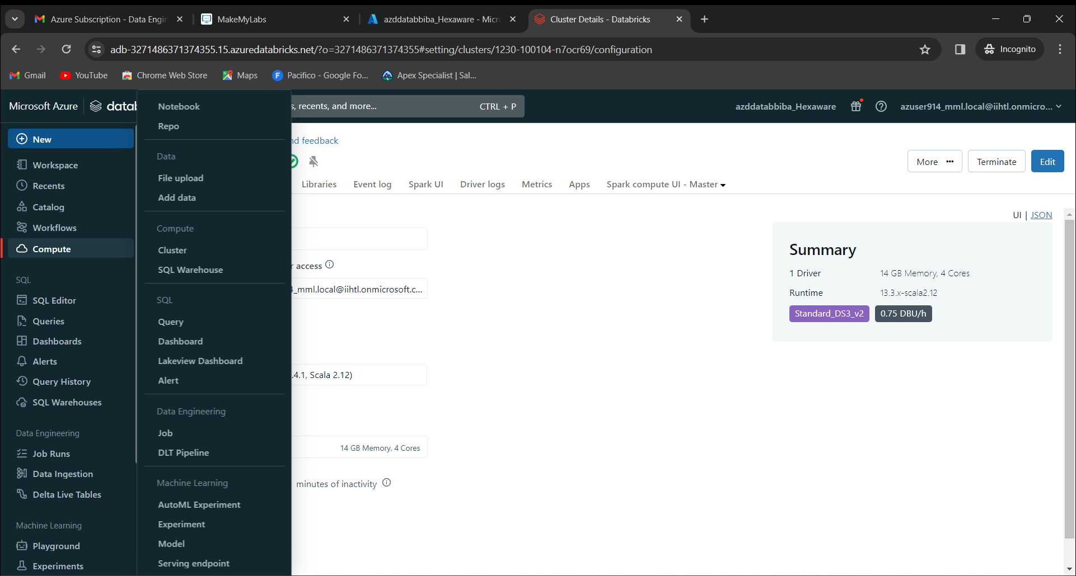

A new notebook will be opened. In that, provide the code and run it.

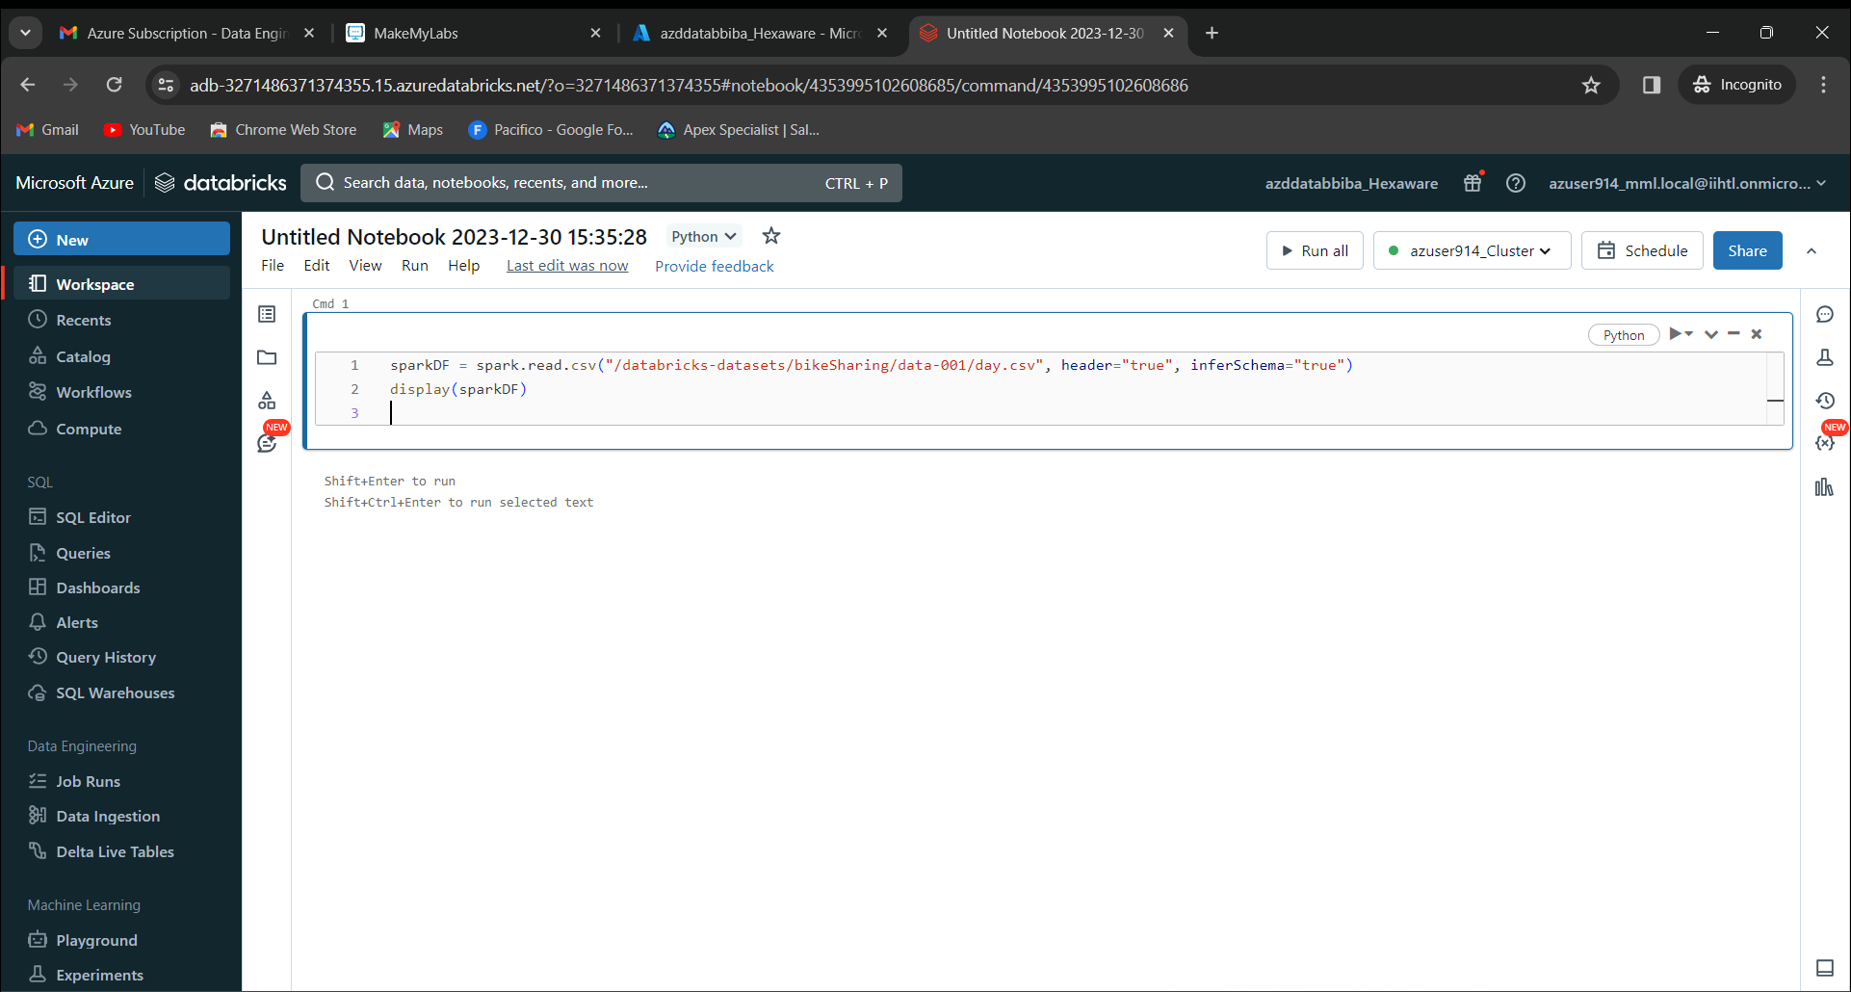

The output will be like as shown below.

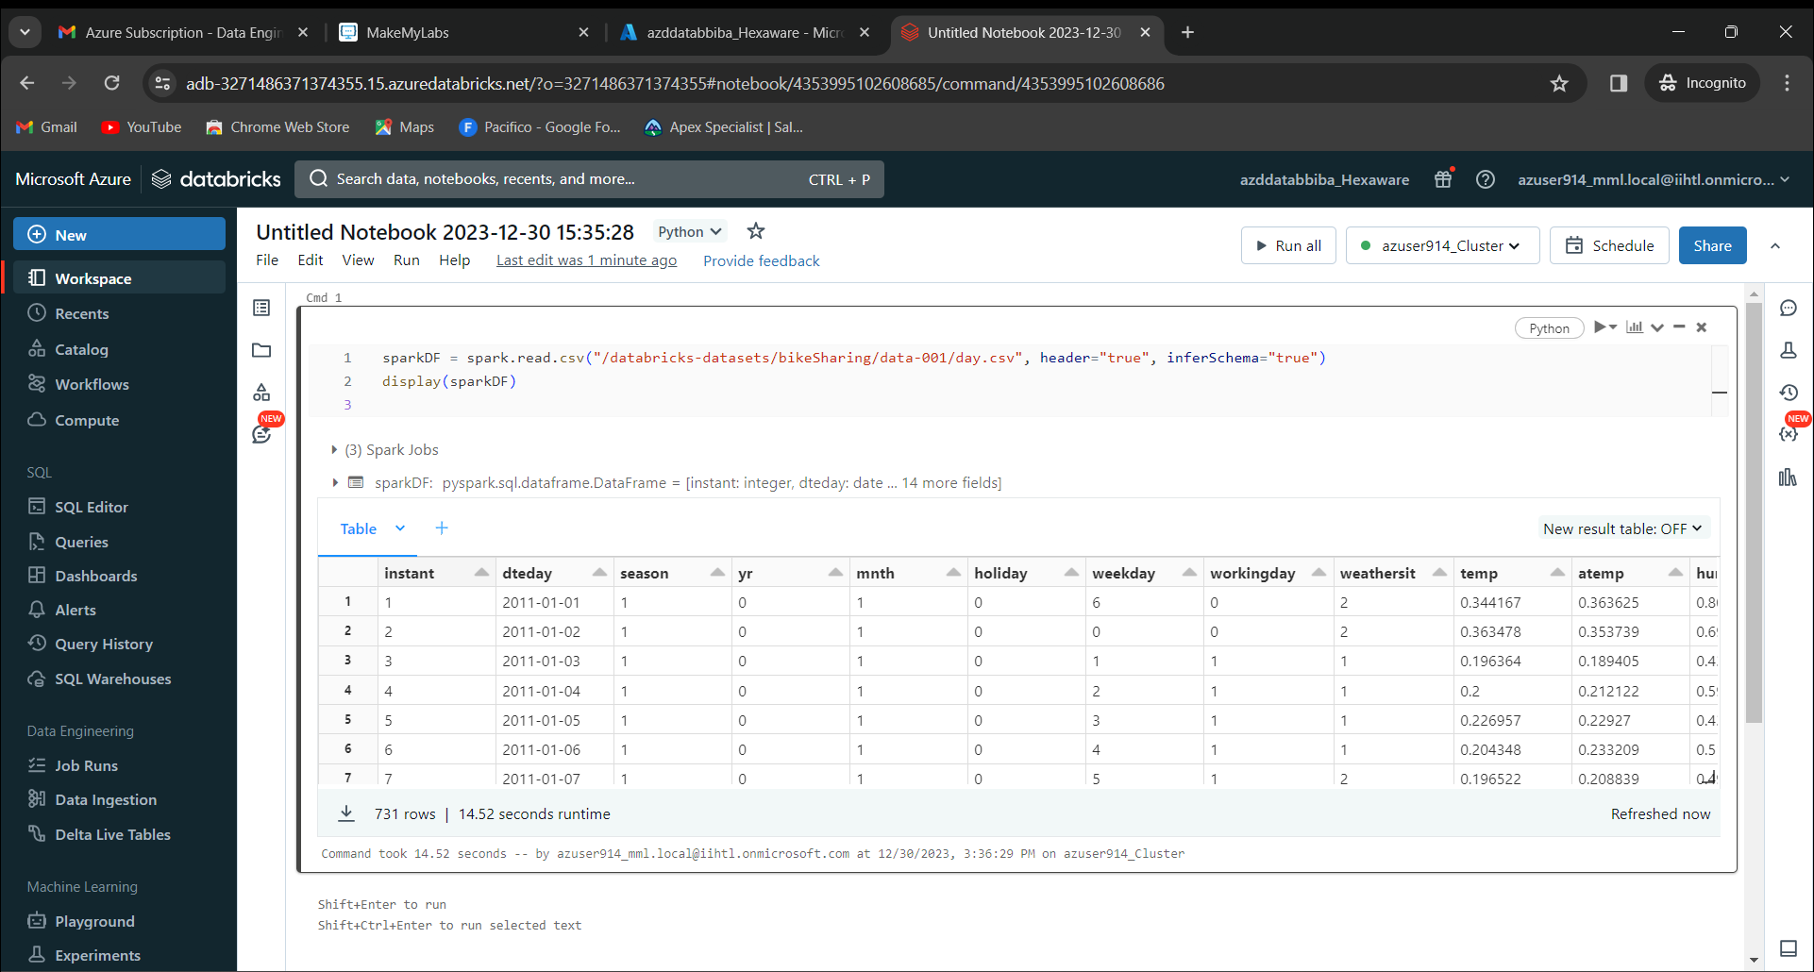

On top of output box, there will be a “+” symbol. Now click on visualization.

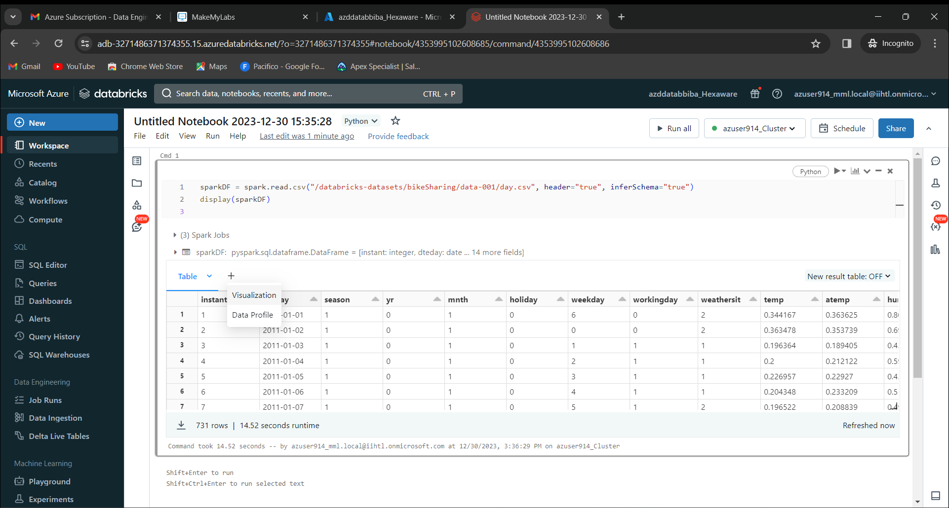

No we get a page like shown below. Provide visualization type as “Scatter”. X column as “atemp”, Y column as “casual” and Group by as “Workingday”. 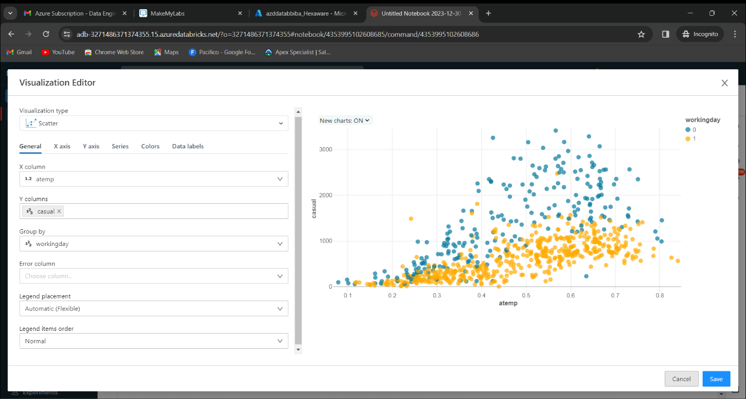

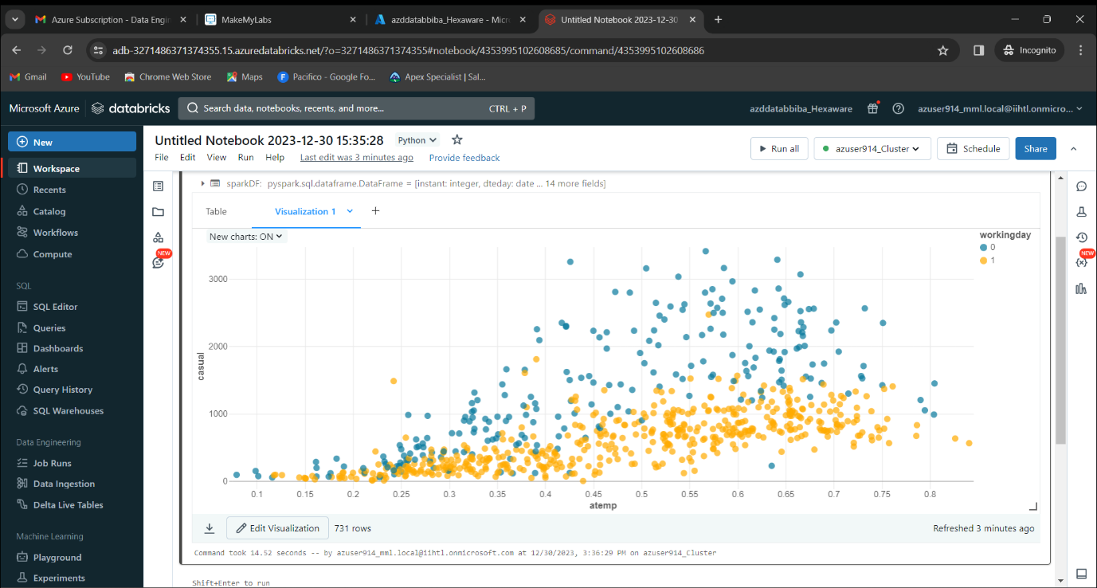

Click on “”save. We get as shown below in the notebook.

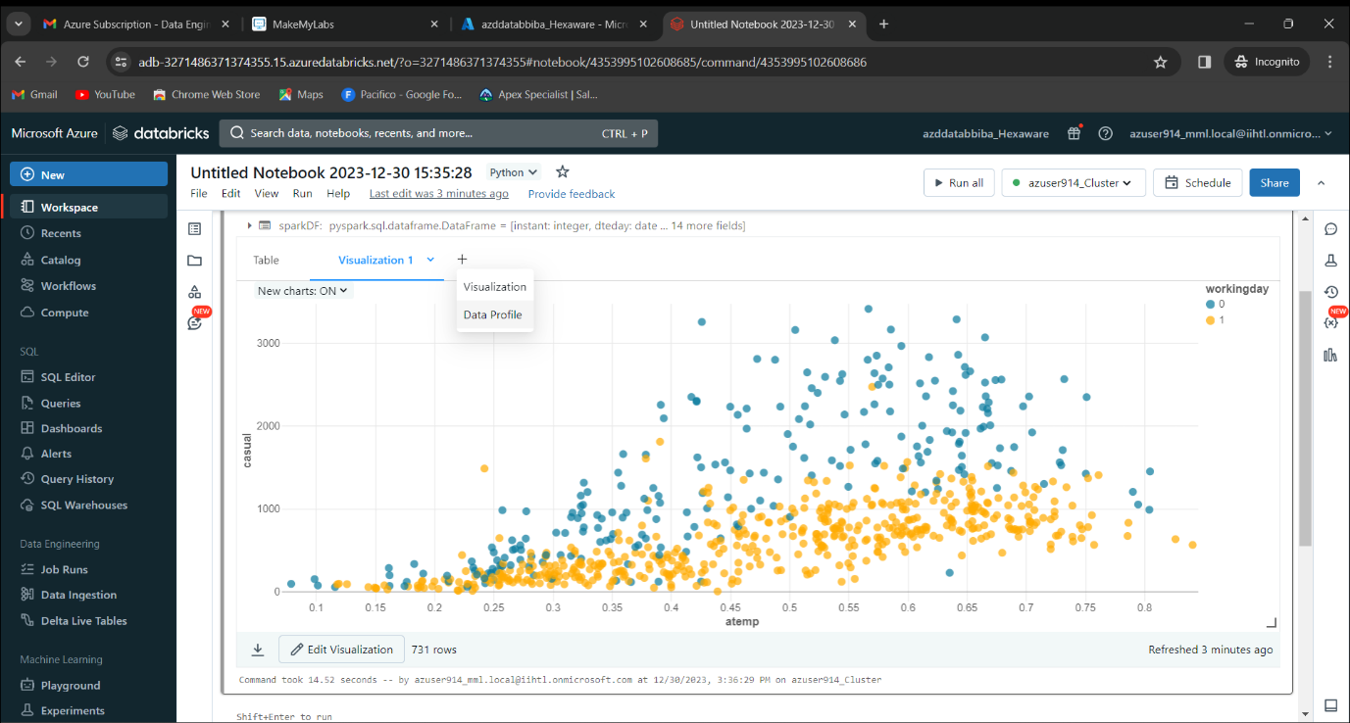Now again click on “+”. We get “data Profile”. Click on it

We get output as shown below.

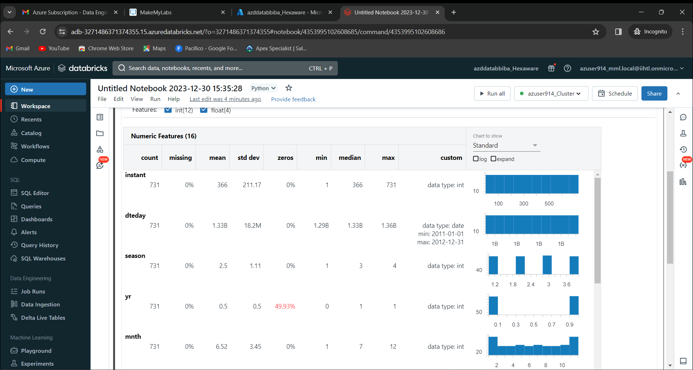

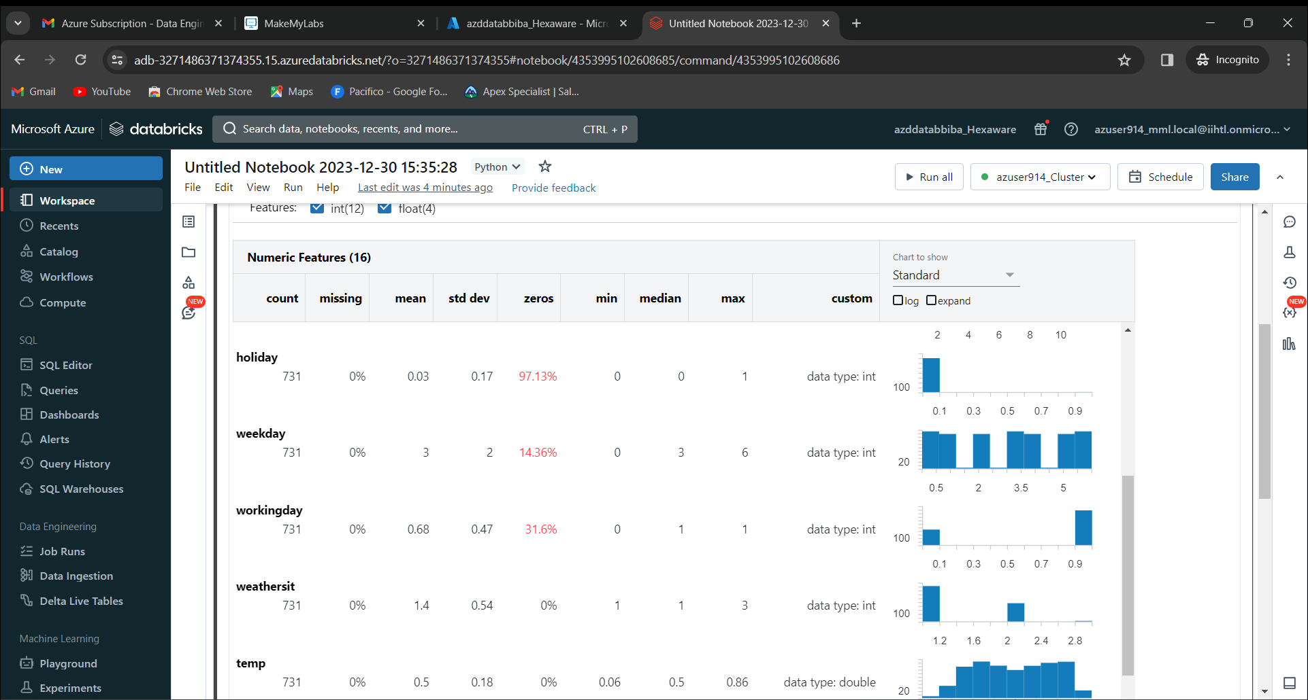

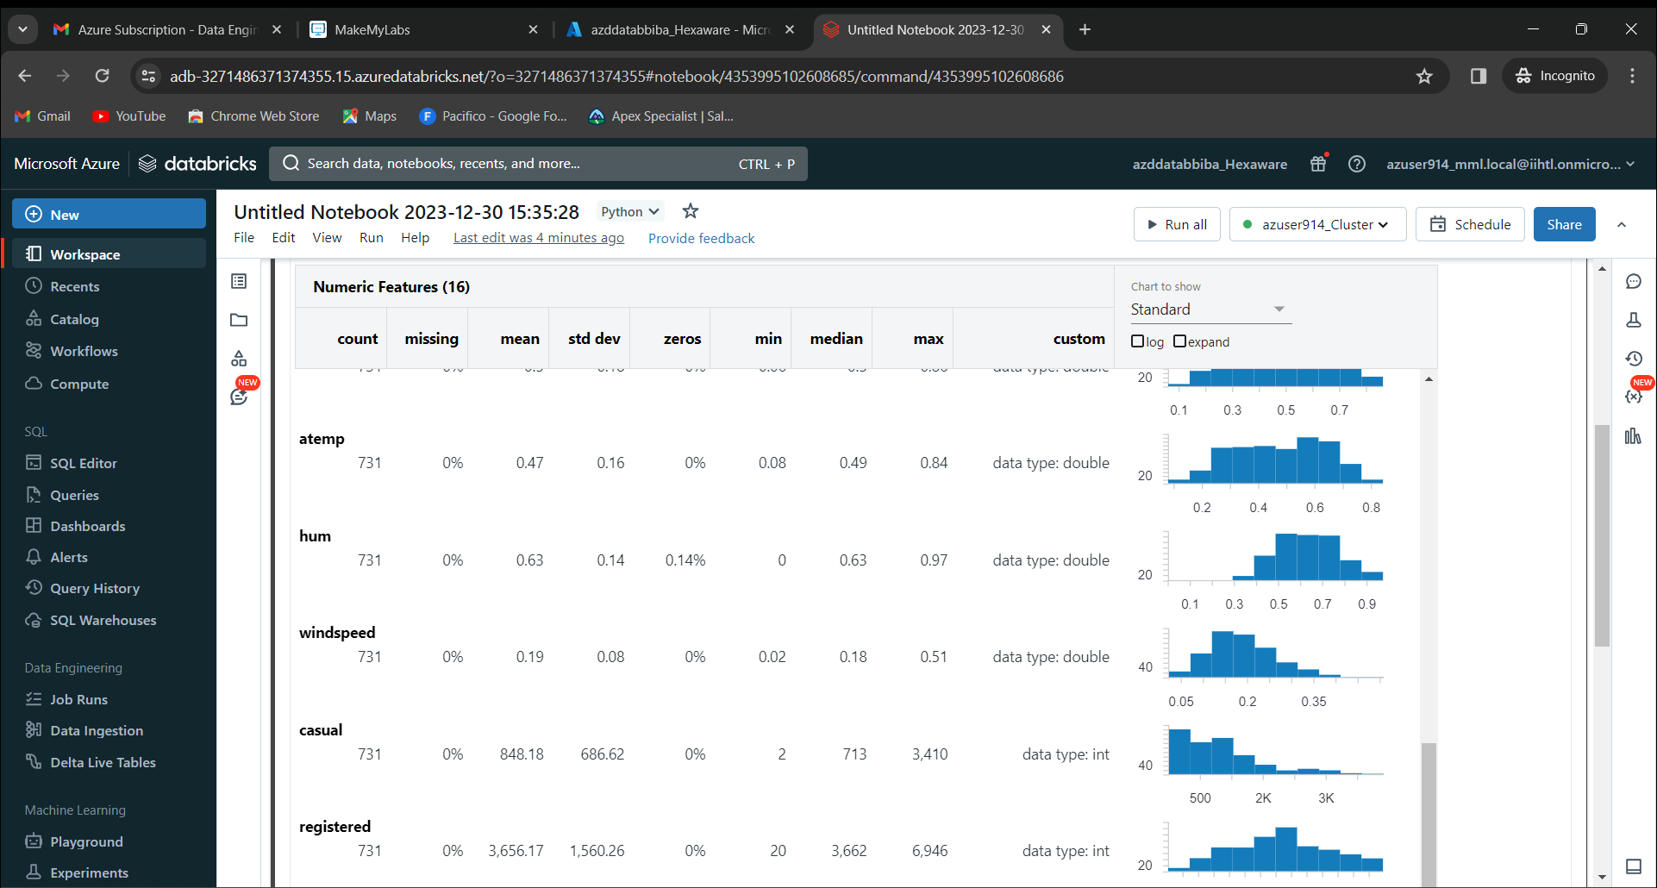

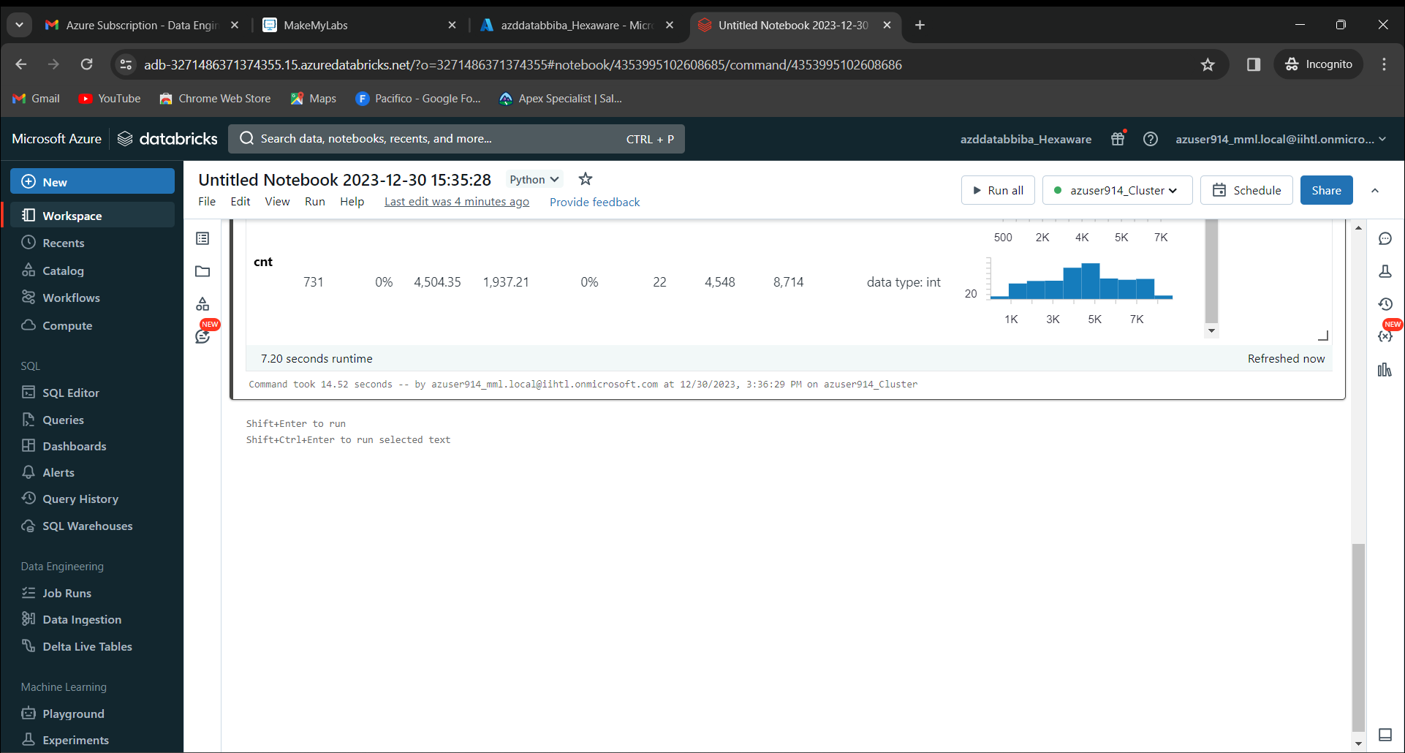

Now to download the graph, click on download button. 